**ROAD ACCIDENT ANALYSIS SQL QUERIES**

**1. CY Casualties:**

SELECT SUM (number_of_casualties) AS CY_Casualties

FROM road_accident

WHERE EXTRACT (YEAR FROM accident_date) = '2022';

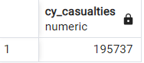

**2. CY Accidents:**

SELECT count (distinct accident_index) AS CY_Accidents

FROM road_accident

WHERE EXTRACT (YEAR FROM accident_date) = '2022';

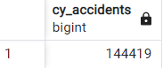

**3. CY Fatal Casualties:**

SELECT SUM (number_of_casualties) AS CY_Fatal_Casualties

FROM road_accident

WHERE EXTRACT (YEAR FROM accident_date) = '2022' and accident_severity = 'Fatal';

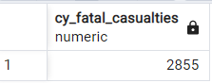

**4. CY Serious Casualties:**

SELECT SUM (number_of_casualties) AS CY_Serious_Casualties

FROM road_accident

WHERE EXTRACT (YEAR FROM accident_date) = '2022' and accident_severity = 'Serious';

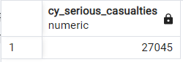

**5. CY Slight Casualties:**

SELECT SUM (number_of_casualties) AS CY_Slight_Casualties

FROM road_accident

WHERE EXTRACT (YEAR FROM accident_date) = '2022' and accident_severity = 'Slight';

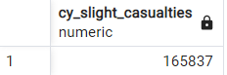

**6. CY Casualties by Vehicle Type:**

SELECT

CASE

WHEN vehicle_type in ('Goods 7.5 tonnes mgw and over','Goods over 3.5t. and under 7.5t','Van / Goods 3.5 tonnes mgw or under') THEN 'Van'

WHEN vehicle_type in ('Car','Taxi/Private hire car') THEN 'Car'

WHEN vehicle_type in ('Bus or coach (17 or more pass seats)','Minibus (8 - 16 passenger seats)') THEN 'Bus'

WHEN vehicle_type in ('Motorcycle 125cc and under','Motorcycle 50cc and under','Motorcycle over 125cc and up to 500cc','Motorcycle over 500cc','Pedal cycle') THEN 'Bike'

WHEN vehicle_type in ('Agricultural vehicle') THEN 'Agricultural'

ELSE 'other'

END AS vehicle_group,

SUM (number_of_casualties) AS CY_Casualties

FROM road_accident

WHERE EXTRACT (YEAR FROM accident_date) = '2022'

GROUP BY

CASE

WHEN vehicle_type in ('Goods 7.5 tonnes mgw and over','Goods over 3.5t. and under 7.5t','Van / Goods 3.5 tonnes mgw or under') THEN 'Van'

WHEN vehicle_type in ('Car','Taxi/Private hire car') THEN 'Car'

WHEN vehicle_type in ('Bus or coach (17 or more pass seats)','Minibus (8 - 16 passenger seats)') THEN 'Bus'

WHEN vehicle_type in ('Motorcycle 125cc and under','Motorcycle 50cc and under','Motorcycle over 125cc and up to 500cc','Motorcycle over 500cc','Pedal cycle') THEN 'Bike'

WHEN vehicle_type in ('Agricultural vehicle') THEN 'Agricultural'

ELSE 'other'

END

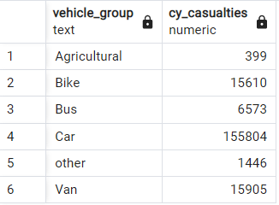

**7. Casualties by Month - Year 2022**

SELECT to_char(accident_date,'Month') AS Month_Name, SUM(number_of_casualties) AS CY_Casualties

FROM road_accident

WHERE EXTRACT (YEAR FROM accident_date)= '2022'

GROUP BY to_char(accident_date,'Month')

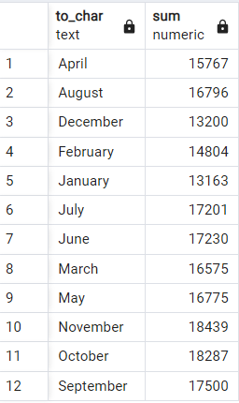

**8.Casualties by Month - Year 2021**

SELECT to_char(accident_date,'Month') AS Month_Name,SUM(number_of_casualties) AS CY_Casualties

FROM road_accident

WHERE EXTRACT (YEAR FROM accident_date) = ‘2021’

GROUP BY to_char(accident_date,'Month')

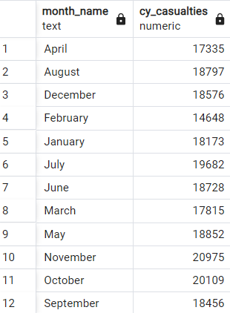

**9. CY CASualties by Road Type**

SELECT road_type, SUM(number_of_casualties) AS CY_CASualties

FROM road_accident

WHERE EXTRACT (YEAR FROM accident_date) = '2022'

GROUP BY road_type

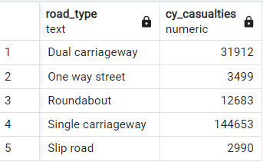

**10. CY Casualties by Urban or Rural Area**

SELECT urban_or_rural_area, SUM(number_of_casualties) *100 /

(SELECT SUM (number_of_casualties) FROM road_accident WHERE EXTRACT(YEAR FROM accident_date)= '2022')AS CY_CASualties

FROM road_accident

WHERE EXTRACT (YEAR FROM accident_date) = '2022'

GROUP BY urban_or_rural_area

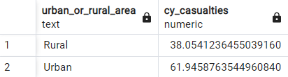

**11. CY Casualties by Light Condition**

SELECT

CASE

WHEN light_conditions in ('Darkness - lighting unknown','Darkness - lights lit','Darkness - lights unlit','Darkness - no lighting') THEN 'Dark'

WHEN light_conditions in ('Daylight') THEN 'Day'

END AS Light_condition,

ROUND (SUM (number_of_casualties) * 100 /

(SELECT SUM (number_of_casualties)

FROM road_accident WHERE EXTRACT(YEAR FROM accident_date) = '2022'),2) AS CY_Casualties

FROM road_accident

WHERE EXTRACT (YEAR FROM accident_date) = '2022'

GROUP BY

CASE

WHEN light_conditions in ('Darkness - lighting unknown','Darkness - lights lit','Darkness - lights unlit','Darkness - no lighting') THEN 'Dark'

WHEN light_conditions in ('Daylight') THEN 'Day'

END

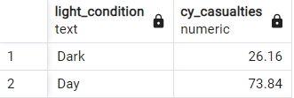

**12. Top 10 Locations by Number of Casualties**

SELECT local_authority, SUM (number_of_casualties) AS Total_Casualties

FROM road_accident

GROUP BY local_authority

order by Total_CASualties desc

limit 10;

